TABLE DESIGN

No:1

Name:Login

Primary key:User_id

Description:This table information is used to login to the site

|  |  |  |  |
| --- | --- | --- | --- |
| SINO | Attribute Name | Data Type | Description |
| 1 | User_id | Integer(15) | pk |
| 2 | User_name | Varchar(30) |  |
| 3 | password | Varchar(30) |  |
| 4 | role_id | Integer(30) |  |

No:2

Name:Role

Primary key:role_id

Description:This table information is used to determine the role of the user

|  |  |  |  |
| --- | --- | --- | --- |
| SINO | Attribute name | Data Type | Description |
| 1 | role_id | Integer(15) | pk |
| 2 | Role | Varchar(30) |  |

No:3

NameP:Country

Primary key:country_id

Description:This table information is used to identify the country

|  |  |  |  |
| --- | --- | --- | --- |
| SINO | Attribute | Data type | Description |
| 1 | Country_id | Integer(15) | pk |
| 2 | Name | Varchar(30) |  |

No:4

NameP:State

Primary key:state_id

Description:This table information is used to identify the state

|  |  |  |  |
| --- | --- | --- | --- |
| SINO | Attribute | Data type | Description |
| 1 | State_id | Integer(15) | pk |
| 2 | Name | Varchar(30) |  |
| 3 | country_id | Integer(15) | fk |

No:5

NameP:District

Primary key:district_id

Description:This table information is used to identify the district

|  |  |  |  |
| --- | --- | --- | --- |
| SINO | Attribute | Data type | Description |
| 1 | district_id | Integer(15) | pk |
| 2 | Name | Varchar(30) |  |
| 3 | state_id | Integer(15) | fk |

No:6

NameP:Old_age_home

Primary key:Home_id

Description:This table information is used to identify the old age homes

|  |  |  |  |
| --- | --- | --- | --- |
| SINO | Attribute | Data Type | Description |
| 1 | Home_id | Integer(15) | pk |
| 2 | Name | Varchar(30) |  |
| 3 | District_id | Integer(15) | fk |
| 4 | Place | Varchar(30) |  |
| 5 | Pincode | Integer(30) |  |
| 6 | Phone_no | Varchar(30) |  |
| 7 | Type | Varchar(30) |  |

No:7

NameP:Registration_booking

Primary key:Reg_id

Description:This table information is used to register to the site

|  |  |  |  |
| --- | --- | --- | --- |
| SINO | Attribute | Data type | Description |
| 1 | Reg_id | Integer(15) | pk |
| 2 | Name | Varchar(30) |  |
| 3 | House_name | Varchar(30) |  |
| 4 | Country_id | Integer(15) | fk |
| 5 | State_id | Integer(15) | fk |
| 6 | District_id | Integer(15) | fk |
| 7 | Place | Varchar(30) |  |
| 8 | Pincode | Varchar(30) |  |
| 9 | Phone_no | Varchar(30) |  |
| 10 | User_name | Varchar(30) |  |
| 11 | password | Varchar(30) |  |

No:8

NameP:Registration_sponsor

Primary key:Sreg_id

Description:This table information is used to register to the site

|  |  |  |  |
| --- | --- | --- | --- |
| SINO | Attribute | Data type | Description |
| 1 | Sreg_id | Integer(15) | pk |
| 2 | Name | Varchar(30) |  |
| 3 | Country_id | Integer(15) | fk |
| 4 | State_id | Integer(15) | fk |
| 5 | District_id | Integer(15) | fk |
| 6 | Place | Varchar(30) |  |
| 7 | Pincode | Varchar(30) |  |
| 8 | Phone_no | Varchar(30) |  |
| 9 | Bank_name | Varchar(30) |  |
| 10 | Account_no | Varchar(30) |  |
| 11 | Gender | Varchar(30) |  |
| 12 | User_name | Varchar(30) |  |
| 13 | password | Varchar(30) |  |
|  |  |  |  |

No:9

NameP:Room_type

Primary key:room_id

Description:This table information is used to describe the type of the room

|  |  |  |  |
| --- | --- | --- | --- |
| SINO | Attribute | Data type | description |
| 1 | Room_id | Integer(15) | pk |
| 2 | Type | Varchar(30) |  |

No:10

NameP:Room_rate

Primary key:rate_id

Description:This table information is used to describe the rate of the room

|  |  |  |  |
| --- | --- | --- | --- |
| SINO | Attribute | Data Type | Description |
| 1 | Rate_id | Integer(15) | pk |
| 2 | Room_id | Integer(15) | fk |
| 3 | Rate | Varchar(30) |  |

No:11

NameP:Health_situation

Primary key:h_id

Description:This table information is used to describe the health situation

|  |  |  |  |
| --- | --- | --- | --- |
| SINO | Attribute | Data type | Description |
| 1 | H_id | Integer(15) | pk |
| 2 | Type | Varchar(30) |  |

No:12

NameP:Booking

Primary key:Booking_id

Description:This table information is used to booking to the old age home

|  |  |  |  |
| --- | --- | --- | --- |
| SINO | Attribute | Data type | Description |
| 1 | Booking_id | Integer(15) | pk |
| 2 | Reg_id | Integer(15) | fk |
| 3 | Name | Varchar(30) |  |
| 4 | Gender | Varchar(30) |  |
| 5 | DOB | Date(30) |  |
| 6 | Phone_no | Varchar(30) |  |
| 7 | Room_id | Integer(15) | fk |
| 8 | Rate_id | Integer(15) | fk |
| 9 | H_id | Integer(15) | fk |

No:13

NameP:Donate_type

Primary key:Dtype_id

Description:This table information is used to describe the donations

|  |  |  |  |
| --- | --- | --- | --- |
| SINO | Attribute | Data type | Description |
| 1 | Dtype_id | Integer(15) | pk |
| 2 | Service | Varchar(30) |  |
| 3 | Product | Varchar(30) |  |

No:14

NameP:Donation

Primary key:D_id

Description:This table information is used to describe the donations

|  |  |  |  |
| --- | --- | --- | --- |
| SINO | Attribute | Data type | Description |
| 1 | D_id | Integer(15) | pk |
| 2 | Sreg_id | Integer(15) | fk |
| 3 | Fdate | date |  |
| 4 | Tdate | date |  |
| 5 | quantity | Varcahar(30) |  |

No:15

NameP:Payment

Primary key:P_id

Description:This table information is used to describe the payments

|  |  |  |  |
| --- | --- | --- | --- |
| SINO | Attribute | Data type | Description |
| 1 | P_id | Integer(15) | Pk |
| 2 | Sreg_id | Integer(15) | Fk |
| 3 | Type_id | Integer(15) | Fk |
| 4 | Rate_id | Integer(15) | Fk |

FORM DESIGN

Login

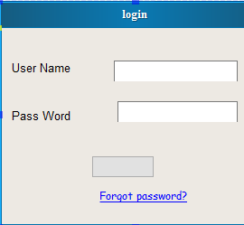

Registration

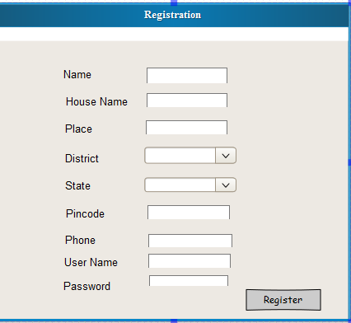

Sponsor Registration

